Salesforce Day 5
Apex Development – Daily Task Documentation
Name: Gunta Sai Koushik
Regd No: 23PA1A4544

Overview
This document summarizes the Apex development tasks completed today for the Placement Application module. The work covers retrieving student and job records with SOQL, validating job eligibility, preventing duplicate applications, persisting a new application record through DML, updating application status based on recruiter decisions, and finally combining all the steps into one complete business transaction. Each task below includes a short description of the work along with supporting screenshots from the Salesforce Developer Console.

Task 1: Retrieve Student Information
In this task, I retrieved the student information using a SOQL query before processing the placement application. Instead of retrieving every field from the Student__c object, I selected only the fields required for eligibility validation, such as the student's name, branch, CGPA, and active backlogs. This helped me understand the importance of retrieving only the necessary data to improve query performance and make the application more efficient.
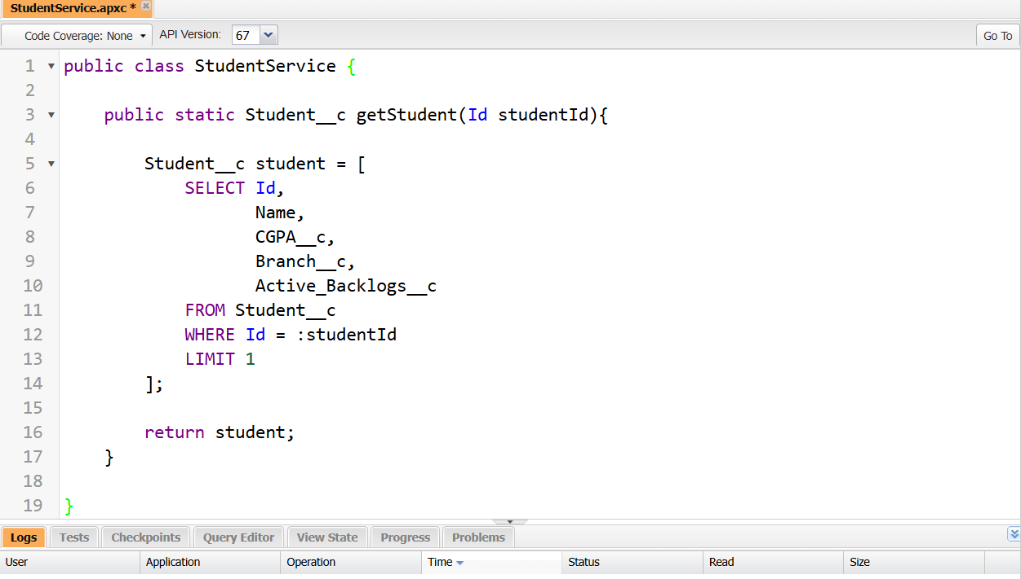
Figure 1.1 — StudentService.getStudent() Apex class retrieving selective fields from Student__c.
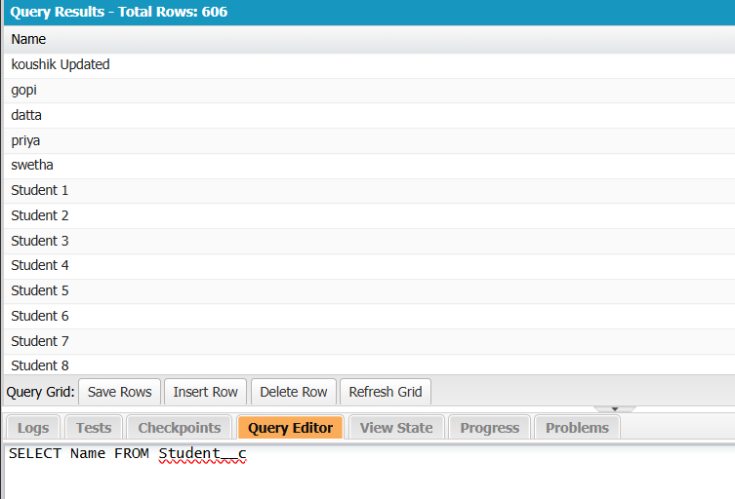
Figure 1.2 — Query Editor results confirming Student__c records (606 rows) queried successfully.

Task 2: Retrieve Job Eligibility Criteria
For this task, I retrieved the selected job record to obtain the company's eligibility criteria. The query fetched only the required details, including the minimum CGPA, eligible branch, maximum allowed backlogs, and application deadline. This information is essential for determining whether a student satisfies the company's placement requirements before proceeding with the application process.
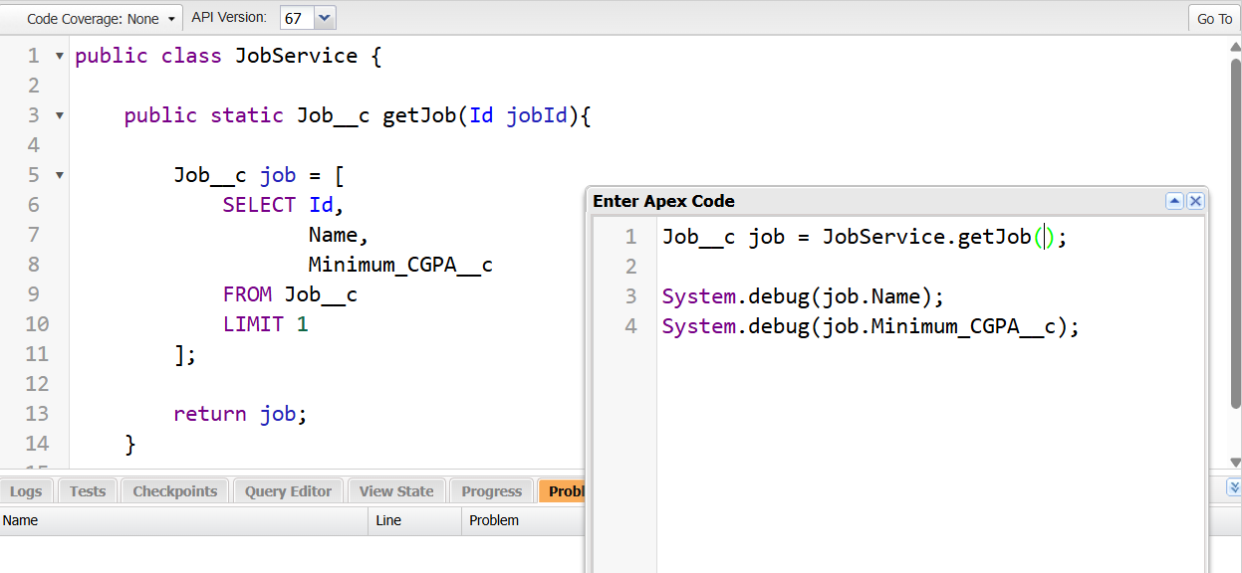
Figure 2.1 — JobService.getJob() Apex class and Execute Anonymous window used to test the method.
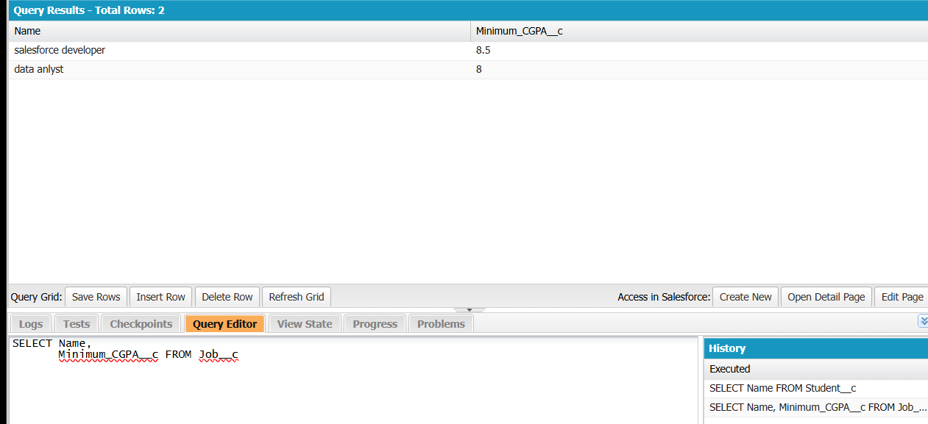
Figure 2.2 — Query results showing Job__c records with Name and Minimum_CGPA__c.

Task 3: Check for Duplicate Applications
In this task, I implemented a validation to prevent duplicate job applications. Using SOQL, I checked whether the student had already applied for the same job. If an existing application was found, the process stopped and an appropriate message was returned instead of creating another record. This ensures that duplicate applications are avoided and keeps the placement data accurate and consistent.
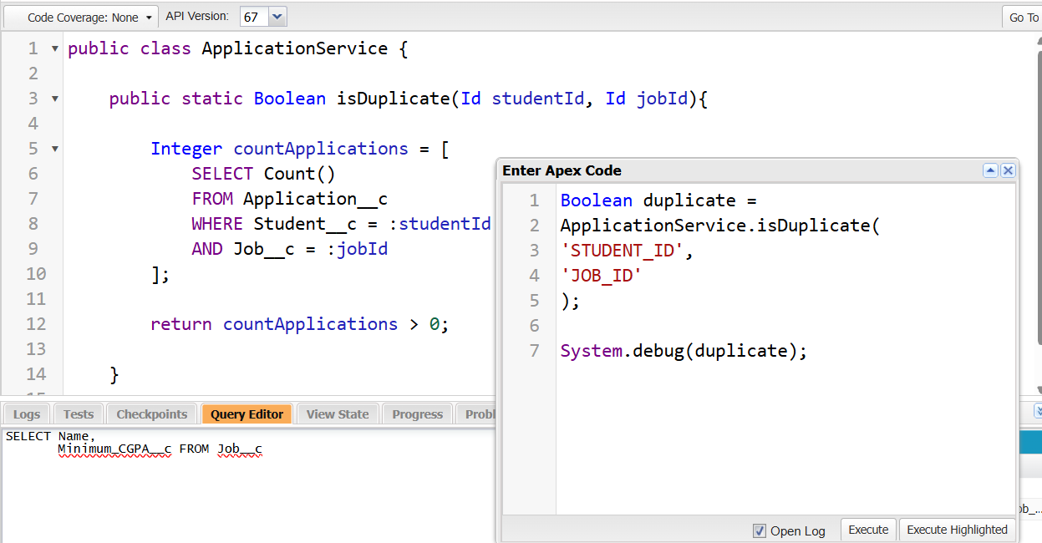
Figure 3.1 — ApplicationService.isDuplicate() Apex class checking for an existing Application__c record.

Task 4: Create and Save Application
After successfully completing all the required validations, I created a new application record using DML. The application record was populated with the student, job, application status, and application date before being saved to Salesforce. This task demonstrated that business data should only be modified after all validation rules have been successfully verified, ensuring the integrity of the placement process.
Note: A screenshot of the DML insert step for this task was not captured during today's session.

Task 5: Update Application Status
In this task, I retrieved an existing application record and updated its status based on the recruiter's decision. Depending on the recruitment stage, the status was changed to values such as Applied, Shortlisted, Interview Scheduled, Selected, or Rejected. After updating the status, I saved the changes using DML and verified that the updated information was reflected correctly in Salesforce.
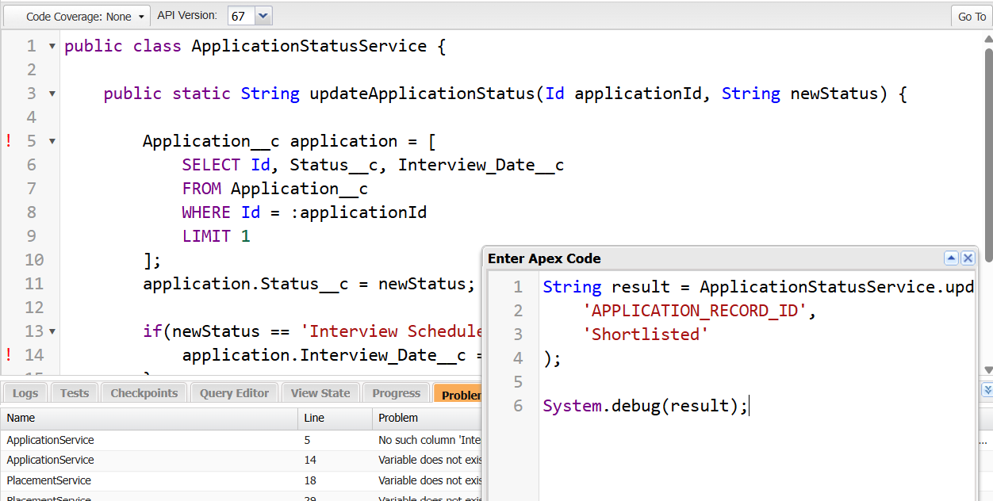
Figure 5.1 — ApplicationStatusService.updateApplicationStatus() Apex class and Execute Anonymous window used to test the method.

Task 6: Complete the Business Transaction
In the final task, I combined all the previous tasks into a complete placement application workflow. The process started by retrieving the student and job details, followed by checking for duplicate applications and validating the student's eligibility. Once all business rules were satisfied, a new application record was created and saved successfully. Finally, a confirmation message was displayed to indicate that the application had been submitted. This task helped me understand how SOQL, DML, and Apex work together to implement a complete business transaction in Salesforce.
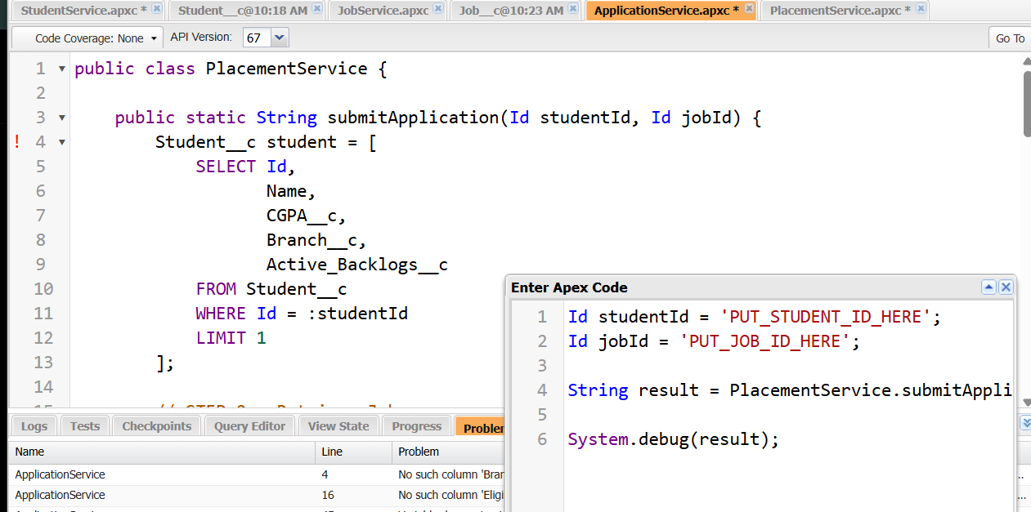
Figure 6.1 — PlacementService.submitApplication() Apex class bringing together eligibility checks, duplicate validation, and application creation.
Summary
Across these six tasks, the placement application flow was built end-to-end: selective retrieval of student and job data, duplicate-application validation, record creation via DML, application status updates driven by recruiter decisions, and finally a unified transaction that ties all the steps together into a single business process. Together these steps ensure that only eligible, non-duplicate applications are saved and tracked accurately, keeping the Placement Application module both efficient and reliable.

